MODULE 5
— Factors, divisibility and mathematical loops
QUES 1. CODE:
bool isPowerOfTwo(int n) {
if (n <= 0) {
return false;
}

while (n % 2 == 0) {
n = n / 2;
}

return n == 1;
}
SCREENSHOT:
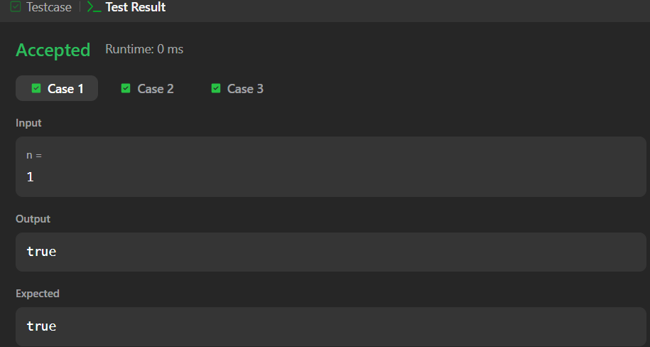
URL: https://leetcode.com/problems/power-of-two/
QUES 2. CODE:
bool isPowerOfThree(int n) {
if (n <= 0) {
return false;
}

while (n % 3 == 0) {
n = n / 3;
}

return n == 1;
}
SCREENSHOT:
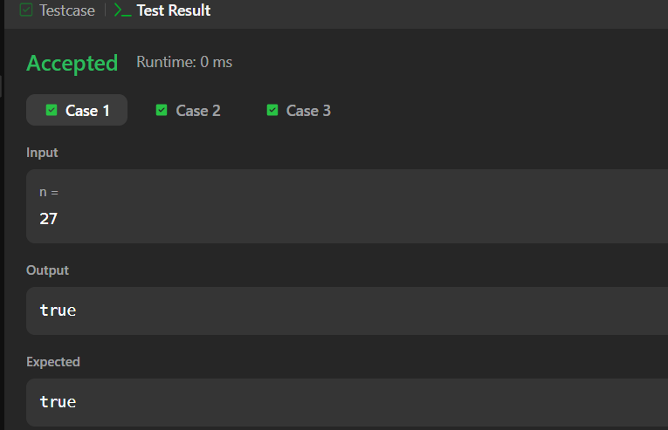
URL: https://leetcode.com/problems/power-of-three/
QUES 3. CODE:
#include <stdio.h>

int main() {
int N;
int fact = 1;

scanf("%d", &N);

for (int i = 1; i <= N; i++) {
fact = fact * i;
}

printf("%d", fact);

return 0;
}
SCREENSHOT:
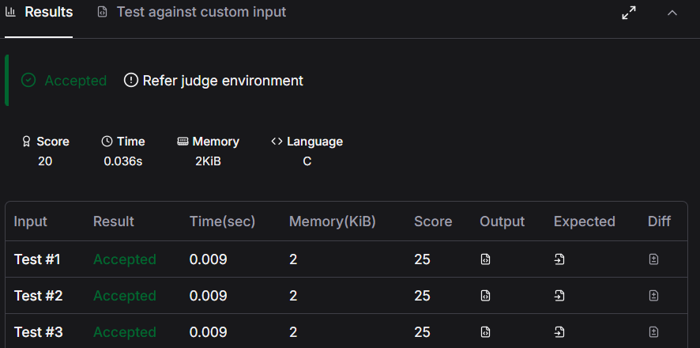
URL: https://www.hackerearth.com/practice/basic-programming/input-output/basics-of-input-output/practice-problems/algorithm/find-factorial/
QUES 4. CODE:
#include <stdio.h>

int main() {
int l, r, k;
int count = 0;

scanf("%d %d %d", &l, &r, &k);

for (int i = l; i <= r; i++) {
if (i % k == 0) {
count++;
}
}

printf("%d", count);

return 0;
}
SCREENSHOT:
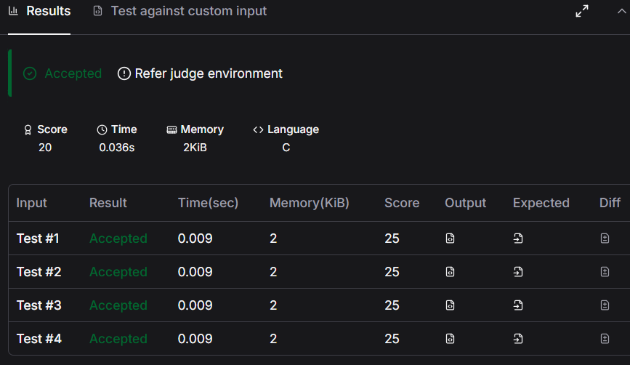
URL: https://www.hackerearth.com/practice/basic-programming/input-output/basics-of-input-output/practice-problems/algorithm/count-divisors/
QUES5. CODE:
#include <stdio.h>

int main() {
int n;
int prime = 1;

scanf("%d", &n);

for (int i = 2; i < n; i++) {
if (n % i == 0) {
prime = 0;
break;
}
}

printf("%d\n", prime);

return 0;
}
SCREENSHOT:
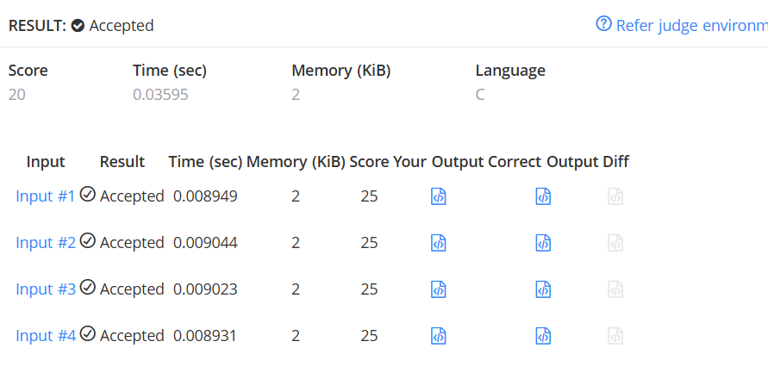
URL: https://www.hackerearth.com/problem/algorithm/prime-numbers/
QUES 6. CODE:
bool checkPerfectNumber(int num) {
int sum = 0;

for (int i = 1; i <= num / 2; i++) {
if (num % i == 0) {
sum = sum + i;
}
}

return sum == num;
}

SCREENSHOT:
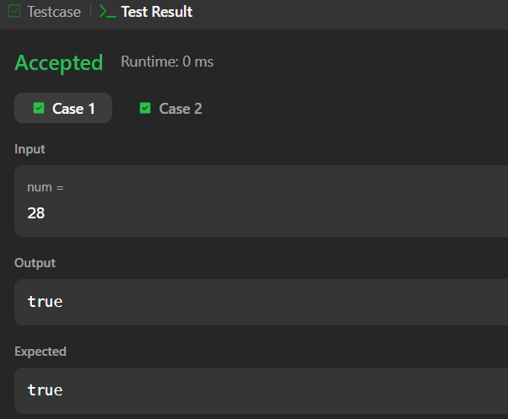
URL: https://leetcode.com/problems/perfect-number/

